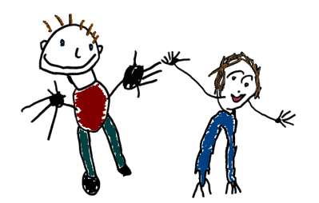
Kea Preschool and Out of School Club
Kea Preschool Limited
Company No: 06701980
Charity No: 1127048
OFSTED No: EY394045

St Kea, Truro, Cornwall, TR3 6AY
01872 260299
www.keapreschool.co.uk
info@keapreschool.co.uk

High quality early education and care for children.

Preschool - Term time only for children aged 2-4 years

...........................................

Wraparound care for children aged 2-11years.

Breakfast club
Afterschool club
Holiday club.

Open 5 days, 51 weeks 7.45am -6.00pm

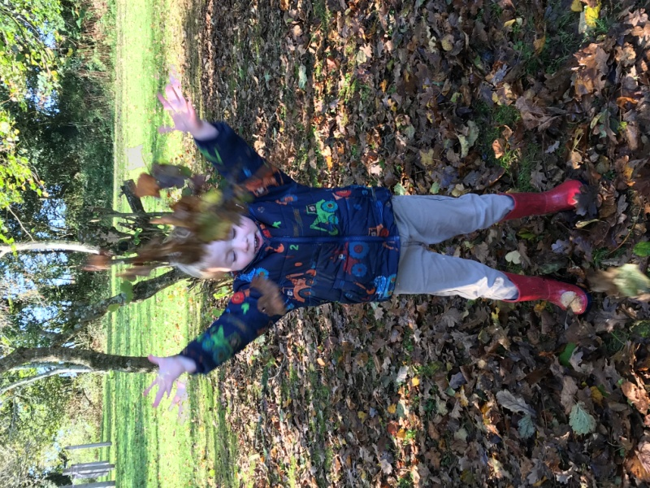
Welcome
Kea Preschool has its own setting, situated in the grounds of Kea CP School, with an outstanding outdoor play area. We provide a safe, stimulating and caring environment that promotes learning through play.
Our setting aims to:
- provide high quality care and education for children
- work in partnership with parents to help children to learn and develop
- add to the life and well-being of the local community
- offer children and their parents a service that promotes equality and values diversity
- foster a love of learning to all
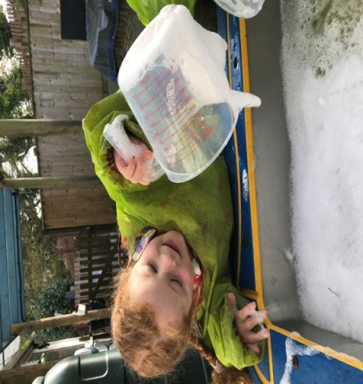
Rated by Ofsted 2019:
The quality of education -
Good
Behaviour and attitudes - Outstanding
Personal development - Outstanding
Leadership and management - Good
Overall effectiveness at previous inspection – Good

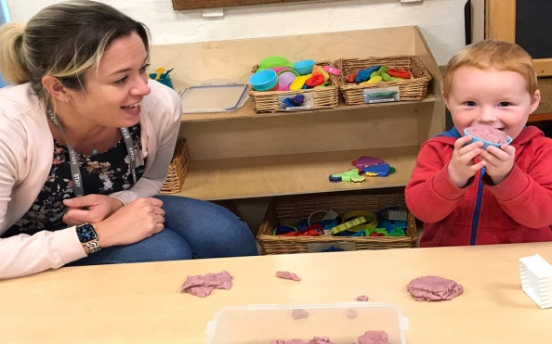
Key person
We use a key person approach. This means that each member of staff has a group of children for whom they are responsible. Your child's key person will be the person who works with you to make sure that what we provide is right for your child.

Our Sessions
9.00am -12.00pm  morning session without lunch | 9.00am - 12.30pm  morning session with lunch | 12.00pm – 3.00pm  afternoon session  (includes lunch) | 12.00pm – 3.30pm  afternoon session with preschool extra session. | 9.00am - 3.30pm  full preschool day

We also run Out of School Club for children aged 2 – 11 years
7.45am – 9.00am  breakfast club | 3.30pm – 6.00pm  afterschool club | 8.00am – 6.00pm  holiday club  (during school holidays)

Children thrive in a learning environment which is stimulating. We follow In the Moment Planning, which allows the children to initiate their own learning through their own individual interests. We recognise that each child is unique!

Outdoor activities contribute to children's health, their physical development and their knowledge of the world around them. We have beautiful surroundings and regularly go on adventures around our environment. Throughout our sessions, children can free flow between the indoor and outdoor areas, allowing the children to choose where they would like to be.
Wellies are a must!

Safeguarding Children
Our setting has a duty to safeguard all children. We have procedures in place for managing complaints or allegations against a member of staff. We work closely with children and their parents, ensuring we are aware of any problems that emerge. We offer support, including referral to appropriate agencies when necessary, to help families in difficulty.
Great care is taken to ensure all children are safe at all times. Child Protection Policies are adhered to and followed. All information related to children is confidential.
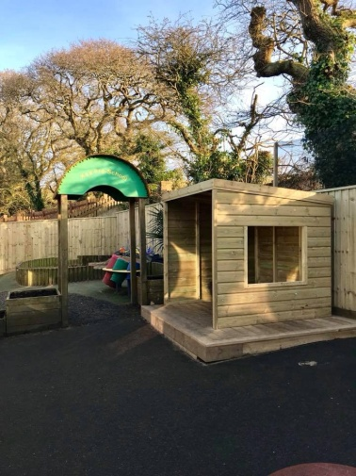
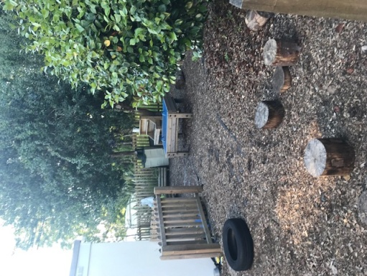
“A rich and stimulating environment
with an exciting range of learning experiences.Children lead their
own play and become confident
and inquisitive learners.
Ofsted 2019

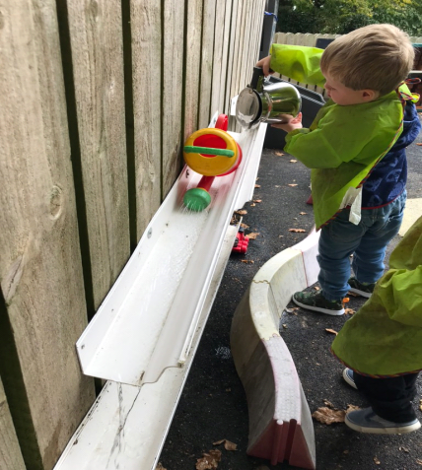
The EYFSCurriculum
Young children have the desire to learn, explore and question. Children start to learn about the world around them from the moment they are born.
Our setting follows the Early Years Foundation Stage statutory guidance to plan and provide a range of play activities, which help children to make progress in each of the areas of learning and development.
We encourage children to be independent and confident and take pride in their own achievements. We love to share 'Wow' Moments!
Parents are also encouraged to share in their child's learning and development.

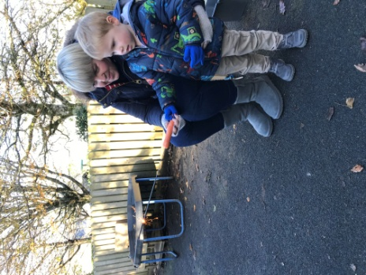
“Children thrive in the care of the highly attentive staff team. The key-persons system is very effective in giving children a firm sense of security and belonging. Staff know children well and value each individual child.” Ofsted 2019

What else we offer at Kea Preschool
We have an outstanding outdoor area which is full of learning opportunities. Children can develop many skills from climbing and balancing on the stepping stones, digging for treasure in our large sandpit, being creative in our wooden shelter to filling and pouring at the water tray.

We are currently developing an outdoor classroom which will enable children to be outside as much as possible. Our outdoor classroom will be every morning and the children will be able to cook up a storm in the mud kitchen, plant seeds and flowers to grow, dig in the mud, build with logs and much more!

Bikes
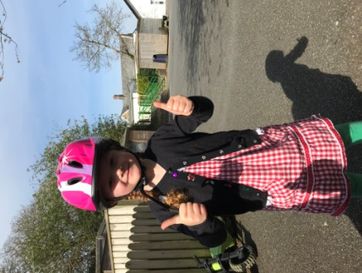
Every Tuesday morning the older children take part in Bike Ability. We put on our helmets and learn the skills to help us balance and then pedal our bikes. We have balance bikes and scooters at Kea Preschool but parents are welcome to bring in their child’s bike from home.

Forest School at Kea Preschool
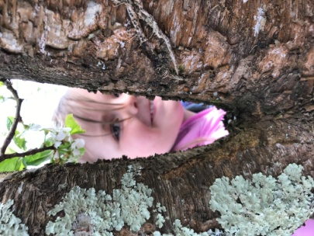
From May/June 2021 we will offer forest school sessions on a Wednesday morning.
Nita, our Forest school leader will take the children on imaginary journeys and discover all about nature, as well as welly walks to the orchards and much more. These sessions will be held onsite at Preschool and within the grounds of Kea School.
More information to follow.

Cooking
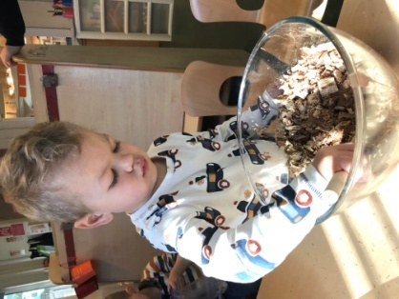
Each Thursday morning the children and staff roll up their sleeves and wash their hands to bake. Every week is something new and the children learn lots of new skills; rolling pastry, mixing mixtures, kneading dough and of course decorating with sprinkles onto biscuits. The children love choosing what to bake the following week.

As well as all these activities, the children enjoy yoga, balancing on bikes and scooters and much more…

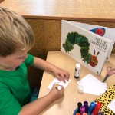

Starting at our setting
We want you and your child to feel happy and safe with us. To make sure that this is the case, the staff will work with you to decide on how to help your child to settle in. We are very flexible with settling in procedures.We recommend booking at least two settling in sessions before your child starts their normal booked in sessions, but we understand that some children may require more settling sessions and will work to gradually building this up.
For the first session we ask that a parent or carer stays with your child.Due to the current situation of Covid-19 we are still asking parents to stay with their child but the settling session will be outside or in the main room away from other children and staff.
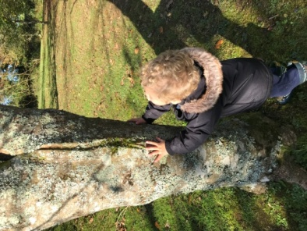

“Children gain a good understanding of nature and the environment in which they live.” Ofsted 2019

Policies
As part of our policy, we ensure that our provision meets the needs of each individual child; we take into account of any special needs a child may have. We understand that every child is different.

Copies of our policies and procedures are available for you to see at the setting or online. The policies help us to make sure that the service provided is a high quality one and that being a member of the setting is an enjoyable and beneficial experience for each child and her/his parents.

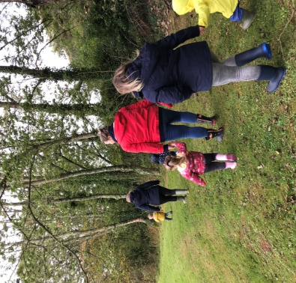
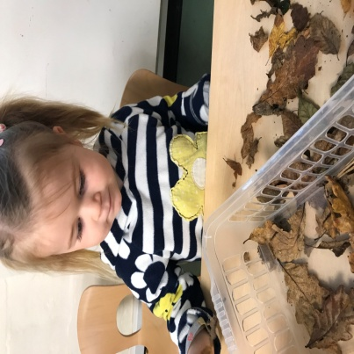
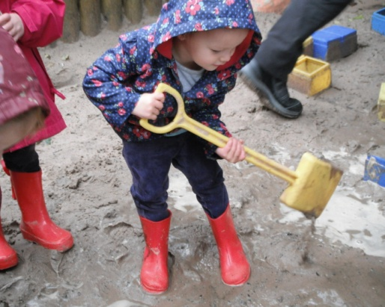

If you would like to find out more about Kea Preschool, please contact us.
info@keapreschool.co.uk
Tel (01872) 260299
