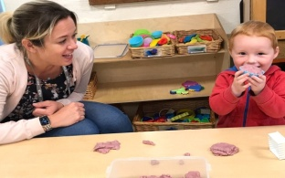

St Kea, Truro, Cornwall, TR3 6AY

01872 260299

[www.keapreschool.co.uk](http://www.keapreschool.co.uk)ter

info@keapreschool.co.uk

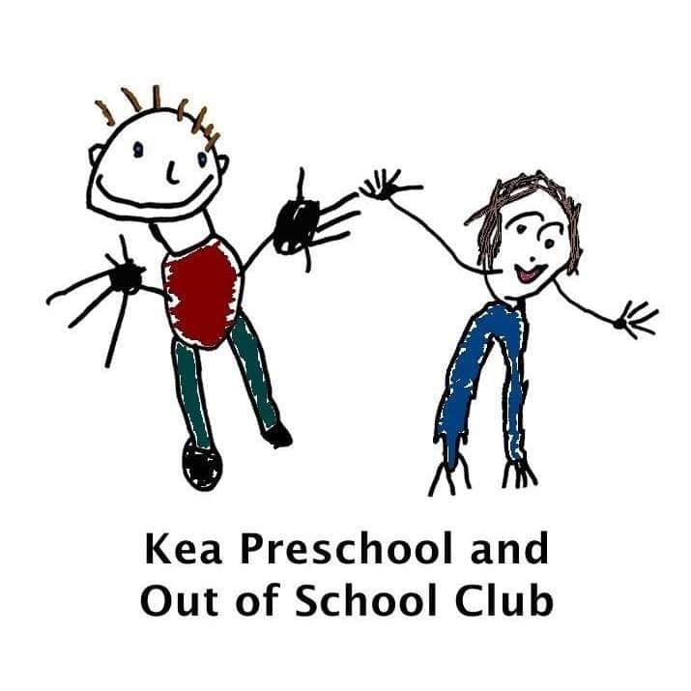

Stay and Play sessions at Kea Preschool.

***We are very excited to be offering FREE stay and play sessions for children aged 18months - 4years (and parents) on the following dates from January 2022. Booking is essential!***

***Our first sessions will run from 9.30am-10.30am on the following dates:***

***Monday 10th January 2022***

***Monday 17th January 2022***

***Monday 24th January 2022***

***Monday 31st January 2022***

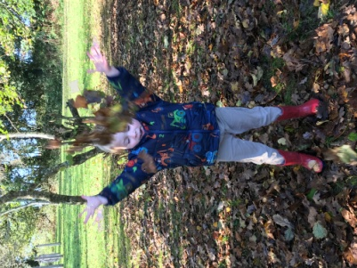

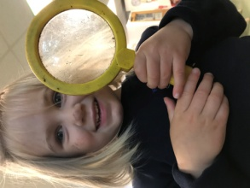

Come along and enjoy a range of activities in our Annex and pop on your waterproofs and wellies to explore our outdoor classroom.

Our stay and play sessions will be a lovely opportunity to make new friends.

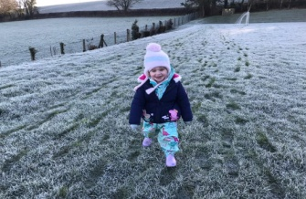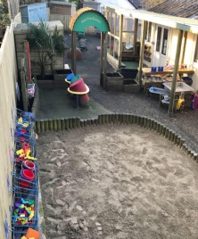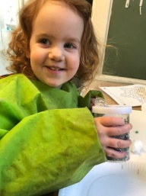

To book, please contact [info@keapreschool.co.uk](mailto:info@keapreschool.co.uk) or call 01872260299

“A rich and stimulating environment” Ofsted 2019

ofsted