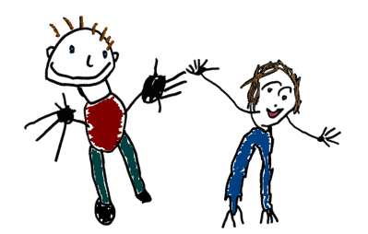
Kea Preschool and Out of School Club
St Kea, Truro, Cornwall, TR3 6AY
01872 260299
www.keapreschool.co.uk
info@keapreschool.co.uk

Kea Preschool Limited
Company No: 06701980
Charity No: 1127048
OFSTED No: EY394045

Holiday Club at Kea Preschool – May Half Term 2022

Name of child....................... Date..................
We will be open throughout the holidays 8am – 6.00pm and CLOSED on Thursday 2nd June and Friday 3 rd June as these dates are a Bank Holiday.
Please state the dates and times you would require below:
Day | Time:
Monday 30th May
Tuesday 31st May
Wednesday 1st June
Thursday 2nd June | Closed – Bank Holiday
Friday 3rd June | Closed – Bank Holiday

Places will be on a first come, first serve basis.
Thank you
Tracey

